Math Worksheet #2.1
- (11-1ex3) Simplify: 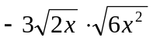
- (11-1ex6) Simplify: 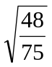
- (11-1ex7) Simplify: 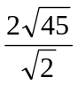
- (11-4ex2) Simplify: 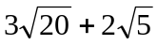
- (11-4ex3) Simplify: 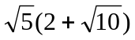
- (11-4ex4) Simplify: 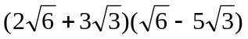
- (11-5) Solve: 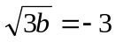
- (12-7ex2) Solve: 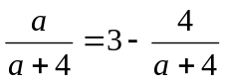
Math Worksheet #2.2
- (11-1ex3) Simplify: 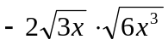
- (11-1ex6) Simplify: 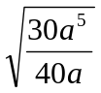
- (11-1ex7) Simplify: 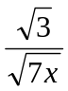
- (11-4ex2) Simplify: 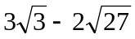
- (11-4ex3) Simplify: 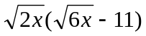
- (11-4ex4) Simplify: 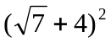
- (11-5) Solve: 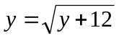
- (12-7ex2) Solve: 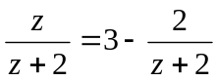
Math Worksheet #2.3
- (11-1ex3) Simplify: 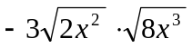
- (11-1ex6) Simplify: 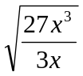
- (11-1ex7) Simplify: 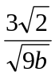
- (11-4ex2) Simplify: 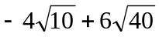
- (11-4ex3) Simplify: 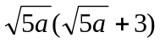
- (11-4ex4) Simplify: 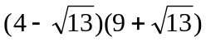
- (11-5) Solve: 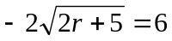
- (12-7ex5) Solve: 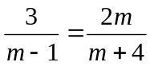
Math Worksheet #2.4
- (11-1ex3) Simplify: 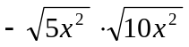
- (11-1ex6) Simplify: 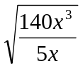
- (11-1ex7) Simplify: 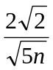
- (11-4ex2) Simplify: 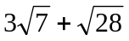
- (11-4ex3) Simplify: 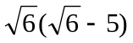
- (11-4ex4) Simplify: 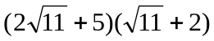
- (11-5) Solve: 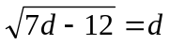
Math Worksheet #2.5
- (11-1ex3) Simplify: 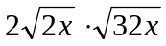
- (11-1ex6) Simplify: 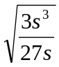
- (11-1ex7) Simplify: 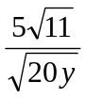
- (11-4ex2) Simplify: 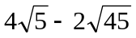
- (11-4ex3) Simplify: 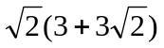
- (11-4ex4) Simplify: 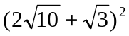
- (11-5) Solve: 